

|  |  |
| --- | --- |
| 131 MURCHISON STREET  HERON HOUSE  LADYSMITH  3370 | TELEPHONE: 082 822 2156  EMAIL: duds.mazibuko@gmail.com |

**ANNUAL REPORT**

**UTHUKELA ECONOMIC DEVELOPMENT**

**AGENCY’S GENERAL INFORMATION**

***REGISTERED NAME:***

***UTHUKELA ECONOMIC DEVELOPMENT AGENCY***

**MANDATE**

* Implement catalytic projects within all Local Municipalities (LM’s)
* Implement RASET and link farmers with markets
* Promote uThukela district as a tourism destination
* Small, Medium and Micro Enterprises support

**Table of Contents**

**PART A: GENERAL INFORMATION** 3

1. HONOURABLE MAYOR’S FOREWORD 3

2. CHAIRPERSON’S STATEMENT 5

3. CEO REVIEW 6

4. STATEMENTS OF RESPONSIBILITY AND CONFRIMATION OF ACCURACY FOR THE ANNUAL REPORT 7

5. STRATEGIC OVERVIEW 8

6. LEGISLATIVE AND OTHER MANDATES 11

7. ORGANISATIONAL STRUCTURE 12

8. ORGANOGRAM 13

**PART B: PERFORMANCE INFORMATION** 15

9. UEDA PROGRAMS 15

**PARTC: GOVERNANCE** 22

10. CORPORATE GOVERNANCE STATEMENT 22

11. AUDIT COMMITTEE REPORT 24

**PART D: ANNUAL FINANCIAL STATEMENTS** 27

12. ANNUAL FINANCIAL STATEMENT 27

# **PART A: GENERAL INFORMATION**

## HONOURABLE MAYOR’S FOREWORD

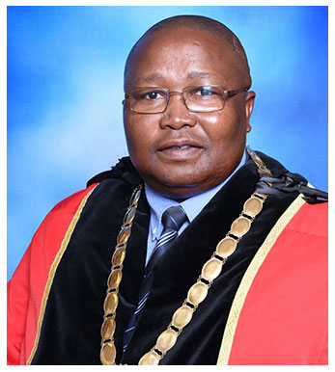

It is with great pride and recognition of all the efforts and work undertaken by the political and administrative leaders and staff, that I present to you the Annual Report for UThukela District Municipality for the 2019/2020 period. The 2019/2020 Annual Report gives a detailed review of the municipality’s activities on actual performance at the end of the fiscal year reporting and further reporting on how the IDP and budget were implemented. It also describes the work of the municipality in fulfilling its Constitutional mandate and in meeting its obligations as dictated by the applicable local government legislation.

**CLLR AS MAZIBUKO**, **MAYOR, UDM**

Chapter 12 of MFMA Section 121 (1) stipulates that every municipality must for each financial year prepare an Annual Report in accordance with this Chapter. UThukela District Municipality has compiled the Annual Report to comply with legislation to give members of community and all stakeholders the performance of the municipality as to how the IDP and budget was implemented. Despite the effects of the economic difficult times, the municipality continued to provide quality service delivery to our community. This report records the progress made by the Municipality in fulfilling its objectives as reflected in the IDP, the Budget and the Service Delivery and Budget Implementation Plan. It also reflects on challenges and priorities for the 2019/2020 financial year.

One of the main reasons for the failure of so many Municipalities in South Africa and the resultant collapses in service delivery is the non-payment of rates and services. No Municipality can function effectively and meet its Constitutional mandate without acceptable levels of income from rates and taxes, without this income a municipality is unable to deliver services and to provide or maintain infrastructure.

I would like to thank all Councillors, for their effective oversight of the municipality’s operations. My sincere thanks to the Municipal Manager, the General Managers and all officials for your contribution to our success rate and diligence to serve this municipality. I also have to express my gratitude to the external Audit Committee for their guidance and oversight role.

**_______________________**

**Cllr AS Mazibuko**

**Mayor: UThukela District Municipality**

## CHAIRPERSON’S STATEMENT



Since its establishment, the agency has played an important role in in contributing to the work needed to achieve economic sustainability and growth within the borders of uThukela District Municipality. The role played by the agency strengthened and placed at the center the facilitation of economic growth and protection of sustainable job creation during the most difficult period in the region, country and the globe due the emergency of the Covid-19 pandemic.

The Covid-19 pandemic affected our district very badly and slowed general economic growth and had negative effects on jobs. During this financial year the Board also experience an untimely passing of one of its members. Despite all this challenges the collaboration and support from some local municipalities help ease the impact of the pandemic.

**MR. S. SHABALALA,**

**BOARD CHAIRPERSON**

As we look at the year ahead, we can only look at the future with much more optimism and determination, we hope for a better and improved working relations between the uThukela District Municipality (shareholder) and all local municipalities within the district. I will like to thank the CEO and staff of the agency for their mystic job in promoting the work of the agency and delivering on their responsibilities.

For the remainder of our term the board will continue to support and guide UEDA in achieving a high standard of performance on its delivery commitments. We as the Board remain focused on ensuring that the entity remains a sustainable, relevant, and efficient entity of the uThukela District Municipality, supporting Alfred Duma, Inkosi Langalibalele Municipality and UKhahlamba Municipality.

**______________________**

**Mr. S. Shabalala**

**Chairperson**

## CEO REVIEW

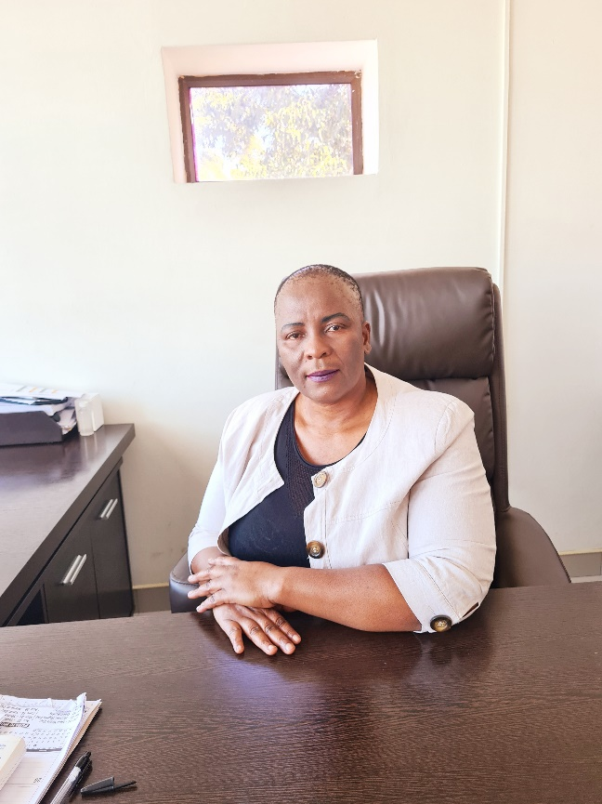**UTHUKELA ECONOMIC DEVELOOMENT AGENCY**

Agency operated in very difficult conditions on the year under review. The main reason was that no budget was allocated by the parent municipality as a result it was very difficult for the agency to execute its mandate.

The support from Alfred Duma LM made it possible for the agency to operate as two people were seconded to the agency

**MS. DCP MAZIBUKO, CEO**

One of the people seconded had to play multiple roles: i.e. board secretary PA to the CEO as well as administration role. The second person seconded had to look after investment as well as people seconded by Okhahlamba and Uthukela District Municipality which were 2 EPWP contract workers.

The RASET grant from COGTA was the only income that the agency had and two months before the end of the financial year, the parent municipality transferred rental grant for 2 years. This gave ease to the Agency as it was constantly threatened wit5h eviction over non-payment and outstanding rental fees.

Despite all the challenges, the Agency operated and was able to develop a strategy on the

3rd quarter of the year under review. This was possible through the program called for Senior Expert Service (SES) offered by German Government. The Agency had applied for this service and DR Cupok came from German and spent 3 weeks helping the Agency to develop as well as participating in the strategy session which was held on the 19th and 20th February 2020! Roadshows were done in only two Municipalities –Uthukela District and

Alfred Duma and before the other 2 LMs were- PARTICULAR HIGHTS OF THE YEAR UNDER REVIEW

**RASET**

The RASET program which was introduced by EDTEA at the provincial level and was allocated a R3m grant by COGTA saw the Agency going around the length and breadth small farmers.

Three Agrihubs were established in all the local Municipalities and renovations were effected in particular Mathews farm Agrihubs at Alfred Duma. During the ease of lockdown, the agency was able to find bean market for the farmers in Bergville

The Agency continues to work very hard in growing the economy of the District.

**_______________________**

**Ms. DCP Mazibuko**

**CEO**

## STATEMENTS OF RESPONSIBILITY AND CONFRIMATION OF ACCURACY FOR THE ANNUAL REPORT

To the best of my knowledge and belief, I confirm the following

1. All information and amount disclosed in the annual report is consistent with the annual financial statements audited by the Auditor-General.
2. The annual report is complete, accurate and is free from any omissions.
3. The annual report has been prepared in accordance with the guidelines on the annual report as issued by National Treasury.
4. The annual Financial statement (Part D) have been prepared in accordance with the Generally Recognised Accounting Practice (GRAP) standards applicable to the Municipal Entity.
5. The accounting authority is responsible for the preparation of the annual financial statements and for the judgment made in this information.
6. The accounting authority is responsibility for the establishing and implementing a system of internal control that has been designed to provide reasonable assurance as to the integrity and reliability of the performance information, the human resource information and the annual financial statement.
7. The external auditors are engaged to express an independent opinion on the annual financial statements.
8. In our opinion, the Annual Report fairly reflects the operations, the performance information, the human resource information and the financial affairs of the public entity for the financial year ended 30 JUNE 2020.

Yours faithfully

**______________________**  **_________________________**

**MS. DCP MAZIBUKO MR. S DLAMINI**

**Chief Executive Officer Acting Chief Financial Officer**

**Date:30 JUNE 2020** **Date: 30 JUNE 2020**

## STRATEGIC OVERVIEW

UThukela Economic Development Agency (UEDA) was established in 2017 informed by the KwaZulu Natal (KZN) Cabinet Lekgotla, which was held on 11-13 September 2012 resolved to establish District Development Agencies. District Economic Development Agencies are key economic drivers identified in the KZN Provincial Growth and Development Strategy (PGDP).

|  |
| --- |
| **UTHUKELA DISTRICT OVERVIEW** |

uThukela District Municipality, which is the parent municipality of uThukela Economic Development Agency; is located on the western boundary of the KwaZulu-Natal Province2. It is bordered by three other district municipalities[:](http://webxsite.co.za/) Amajuba, uMzinyathi and uMgungundlovu. It consists of three local municipalities:

* Okhahlamba;
* Alfred Duma and;
* Inkosi Langalibalele.

The district derives its name from one of the major rivers in KwaZulu-Natal, the uThukela River, which rises from the Drakensberg Mountains and supplies water to a large portion of KZN, as well as Gauteng.

It is predominately rural and is characterised by poor socio-economic indicators such as low revenue base, poor infrastructure, limited access to services, and low economic base. Cities/Towns:

* Bergville;
* Cathkin Park;
* Colenso;
* Estcourt;
* Ladysmith;
* Van Reenen;
* Weenen;
* Winterton

Main Economic Sectors:

* Manufacturing (21%);
* Wholesale and Retail Trade, Catering and Accommodation (17%);
* Finance, Insurance, Real Estate and Business Services (15%)

Map

1:

uThukela District Municipal Area

Source: uThukela District Muni

cipality Websi

te

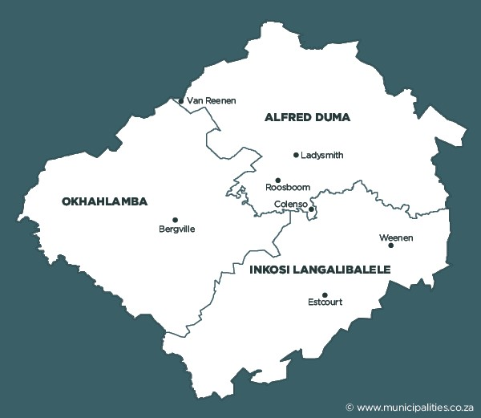

|  |
| --- |
| **VISION** |

An economically vibrant and prosperous district that retains and attracts businesses encored in unique opportunities and innovation for sustainable economic development.

|  |
| --- |
| **MISSION** |

Create an enabling and business friendly environment thus ensuring the retention and attraction of local and international investments and promote new business ventures working with all social and business partners for achieve a prosperous sustainable economic development for uThukela District.

|  |
| --- |
| **OBJECTIVES** |

The main objectives:

* To create an enabling and conducive environment for both local and international businesses to thrive.
* To facilitate, coordinate and monitor all district economic development projects.
* To restore business confidence stakeholder engagements and establishment of the economic development working group.
* To mobilize and promote the use of local resources and skills thus ensuring maximum local economic development.

**KEY SERVICES**

The typical mandates of UEDA include the following:

* Improve the economic context and opportunity of the territory.
* Fundraising and implementation on high-impact projects.
* Promote competition among healthy businesses.
* Provide tools for economic development that include the weakest and most vulnerable sectors.
* Develop relationships of collaboration and cooperation across sectors.
* To manage the spatial organization of the area in a socially efficient manner, particularly through the use of public land & targeted private projects.
* stimulating of economic development through development projects and investment support/promotion.
* The identification of catalytic projects.
* Focusing on sector competitiveness such as Industrialisation; Tourism; agriculture, job creation, and high impact projects; Business Development Services and SME support, communication, property management, mediation between public and private sectors, poverty alleviation and small-town regeneration.

## LEGISLATIVE AND OTHER MANDATES

UEDA is a municipal entity that was established by a resolution of KZN Cabinet Legotla of September 2012 is required to comply with the following:

* Municipal Systems Act (MSA);
* Municipal Finance Management Act (MFMA);
* National Development Plan (NDP);
* Treasury Regulations;
* Policies and directives of the Department of Cooperative Governance and Traditional Affairs (COGTA);
* District, Provincial and National Priorities;
* Uthukela District, KZN and National Economic Recovery Plans;
* Provincial Growth and Development Plan; and
* Memorandum of Understanding signed with various countries around the world.

## ORGANISATIONAL STRUCTURE

**BOARD OF DIRECTORS**

|  |  |  |  |
| --- | --- | --- | --- |
| **TITTLE** | **INITIALS AND SUR** | **DESIGNATION** | **STATUS** |
| Mr | S. Shabalala | Chairperson |  |
| Mr | P.A Stockhill | Deputy Chairperson |  |
| Mrs | M Asmal | Board Member |  |
| Mr | A.M Msomi | Board Member |  |
| Rev | K.D Nduli | Board Member |  |
| Mr | J.M Mosia | Board Member | Deceased |
| Mr | O.D Amla | Board Member | Resigned |

## ORGANOGRAM



FINANCE

PROJECTS

S DLAMINI

ACTING CHIEF FINANCIAL OFFICER

VACANT

MANAGER SCM

VACANT

MANAGER FINANCE

BD MADIKIZELA

ACTING GENERAL MANAGER: PROJECTS

N BUTHELEZI

ACTING MANAGER: RASET

L MOORCROFT

Executive PA/Board Secretary

CEO

DCP MAZIBUKO

CEO

N MAZIBUKO

AGRICULTURAL ASSISTANT

L MUNGWE

ACTING RECEPTIONIST

VACANT

CLEANER/REFRESHMENTS

VACANT

ADMIN & HR OFFICER

VACANT

MANAGER: TOURISM

S SIMELANE

ACTING DRIVER

OCCUPIED

**STRATEGIC PARTNERS**

UEDA has through a number of strategic partnerships, aligned itself with like-minded stakeholders with a view to synergistically and consistently promote UThukela District’s attributes.

Such linkages have seen a number of effective collaborations on projects within the district that makes the Agency effective and efficient in its endeavour to fulfil its mandate.

**Key strategic partners include:**

1. Public entities.
2. Financial institutions.
3. Tertiary educational & research institutions.
4. Municipalities in Uthukela District.
5. The Business Chamber movement, at both local and district level.
6. Trade & Investment KwaZulu-Natal.
7. Other Economic development agencies (national and international)
8. Provincial and national government departments.

# **PART B: PERFORMANCE INFORMATION**

## UEDA PROGRAMS

**RASET AND AGRICULTURE**

**RASET**

Radical Agrarian Socio Economic Transformation (RASET) meetings are held on a monthly basis. Farmers have been engaged. A database with farmers in the District has been created and visits will be conducted to complete the outstanding information once the vehicles are ready to be utilized.

The renovations of Matthew’s farm have been completed and is ready to use. The Okhahlamba fresh produce market can be used by the Agency for RASET purposes, the Agency was invited by the council to do a presentation on its utilization but the council decided to open it for public bidding, the Agency was also invited for bidding. The Agency is waiting to hear if it was successful on bidding.

**Matthew’s Farm Agri-Hub**

The renovations of Matthew’s Farm in the Alfred Duma Local Municipality has been completed and is ready to be utilized for packing and processing in respect of the RASET program.

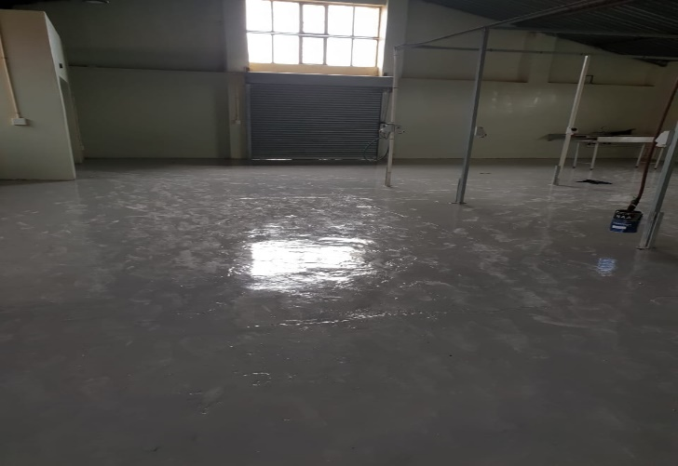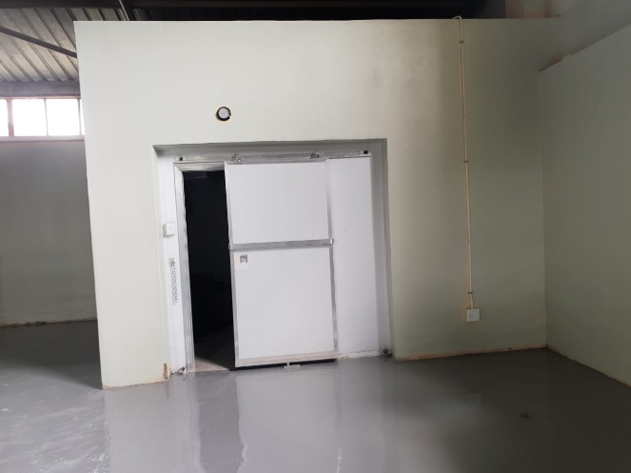

**Vehicles for the RASET program**

Two vehicles have been bought for purposes of collecting and delivering vegetables and dry goods for the RASET program.

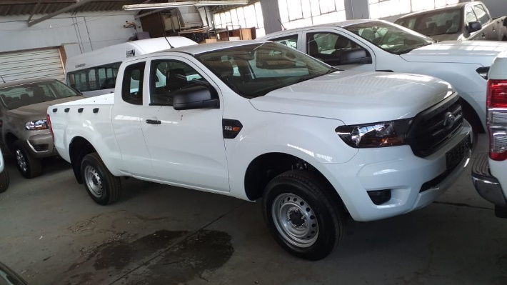 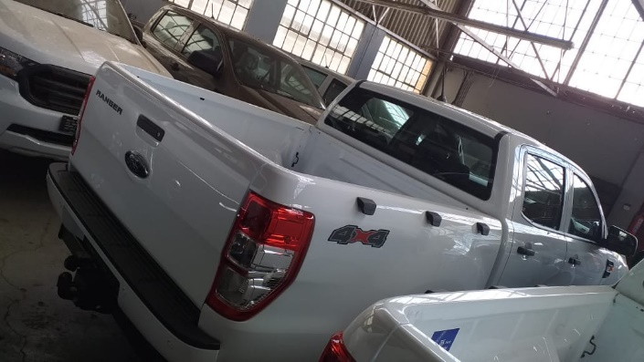

**UMgungundlovu Site Visit**

A site visit was conducted to the UMgungundlovu Economic Development Agency (UMEDA) for benchmarking purposes. Our visit was to Mkhondeni Fresh Produce Market where UMEDA was delivering fresh produce to Department of Social Development trucks. This has assisted UEDA tremendously, especially for the preparation of the signing of the same contract with DSD.

**Department of Social Development**

A meeting with the Department of Social Development was held and discussions in relation to signing an MOU with the Agency has been held to supply vegetables and dry goods to the Department once the pack-houses are ready for utilization.

**Meeting with PCK Distributors**

On 11 February 2020 UEDA had a meeting with PCK Distributors in their offices in Durban. The purpose of the meeting was to negotiate with PCK to purchase some of the vegetables they supply to hospitals in Uthukela District from emerging farmers within the district. The meeting was a success, they agreed to the idea and all that was left was for the Agency and DARD to get farmers ready to produce the required quantities of the right quality.

**AGRICULTURE**

**Steinberg Piggery Farm visit**

The Steinberg Piggery farm is situated in Okhahlamba Local Municipality; this project was initially from Denmark but has now been sold to a South African investor residing in the Western Cape. The project value is currently not known because when the Agency visited the site, only the constructor was on site. The construction for the first phase is almost completed and it is expected that by the end of April 2020, it will be up and running.

UEDA is planning to work with the former tenants of the farm who have been relocated to their land, to plant maize that will be bought by the piggery for the pigs’ feed.

**Revival of Chicory Farming and Processing**

The Agency visited the Nestle factory as part of meet and greet with the Nestle management, on discussions Nestle explained the value chain they have which can help in creating job opportunities within the district. One of those opportunities involved chicory planting which is currently imported from India. Previously there were attempts by Nestle to help farmers especially from the Weenen area to plant chicory. The project failed due to mishandling. The project has a great opportunity and can help in reducing the imports. The Agency has embarked on reviving this project and has met with all the relevant stakeholders including Nestle and ADA who provided the funding.

The Agency has initiated monthly meetings with the relevant stakeholders, a business plan is being prepared by ADA for the project. The Agency is due to visit chicory SA in Port Elizabeth for benchmarking as well as to see what type of roaster will be needed for the project.

UEDA has approached Nestle to negotiate an off- take agreement with Ubumbano and the steps to finalise the agreement are ongoing. UEDA has facilitated reregistration of Ubumbano, opening of a new bank account and a tax clearance certificate in order to apply for funding on their behalf from potential funders.

**Agricultural activities during Covid-19 lockdown**

During June 2020 Uthukela Economic Development Agency visited cooperatives and individual farmers within Uthukela District to make them aware of the COVID 19 Agricultural Disaster Support Fund for smallholder and communal farmers. There was also a request proposal from the Department of small business development for small and emerging farmers and agro-processors to supply certain vegetables and fruits. Farmers who produce beans, butternut, ground nuts, soya beans, cabbage, potatoes and garlic from the following areas within Uthukela District were visited:

Inkosi Langalibalele Local Municipality

* Weenen
* Nkaseni
* Loskop
* Emandabeni

Alfred Duma Local Municipality

* Mngwenya
* Pholweni
* Magodleni
* Sahlumbe
* Lusitania

Okhahlamba Local Municipality

* Emahlutshini
* Emazizini
* Emaswazini
* Geluksburg
* Greenpoint

**INVESTMENTS**

**COLENSO POWER**

This project is situated in Colenso, Alfred Duma Local Municipality but it also boarders at the Inkosi Langalibalele Local Municipality. The value of this project is R6 Billion and will create approximately 6000 job opportunities. The project started about 9 years ago. The investor, Mr John James wanted to build a coal power station using mainly the coal that will be mined in the area. The project has had serious delays especially from the Department of Mineral and Energy. All the studies have been completed by the investor. The Agency called a meeting with all the relevant stakeholders so as to fast-track the activities. The investor reported in the meeting that he was no longer moving ahead with the power station construction but was rather focusing on gasification.

The investor is busy with the adjustment of the Environmental Impact Assessment (EIA). The Agency has assisted to link the investor with Afrexim Bank which will assist funding of the project.

**SMELTER PROJECT**

This project was initiated about 7 years ago, initially it was located at Colenso Alfred Duma Local Municipality but had to move to Escourt, Inkosi Langalibalele Local Municipality due to the Smelter, because of the smoke it produces it cannot be in the same vicinity with households (yet it is in the same Colenso belt). The project is valued at R20 Billion and will create about 8000 job opportunities in the area.

There have been serious delays in this project which were caused by changes in the structure of SINOSA. Other challenges were caused by the Department of Agriculture, Land Reform and Rural Development delaying to give land to the investor. The investor had to find a valuator for the land which has happened. The investor is now busy negotiating with the current lessees and tenants so that they can be moved and the EIA processes will take place.

**AFRISTARCH**

The Agency was approached by an investor who wanted to establish a factory that will manufacture pharmaceutical starch from maize. This project will be situated in Colenso because of its proximity to water. The investor has formed a partnership with National Empowerment Fund as a funder and a partner.

The value of the investment will be R400 Million. More than 200 permanent job opportunities will be created when the project is running.

The investor has asked for the Agency to assist in locating and acquiring suitable land from Alfred Duma Local Municipality. Suitable land was identified in Colenso and a submission to Alfred Duma Municipal was made and EIA processes have been initiated.

**SUMITOMO RUBBER INDUSTRIES**

Sumitomo Rubber Industries is an existing tyre manufacturer located in Ladysmith. They produce both car and truck tyres under the Dunlop Brand.

The Agency has approached Sumitomo to unlock some of their value chain to empower Small Medium and Micro Enterprises (SMME’s) that are owned by the previously disadvantaged groups in Uthukela District.

Sumitomo identified warehousing for their tyres as one of the areas they can outsource to these SMME’s. A company owned by young people from Steadville was given an opportunity to pitch and they had to present a business plan. The Agency and Sumitomo negotiated with Ithala Industrial Estate for the warehouse.

**EFFORT TO ESTABLISH AN SEZ WITHIN UTHUKELA DISTRICT**

UEDA hosted a meeting during January 2020 to discuss the possibility of applying for a special economic zone within Uthukela District. The meeting established that there is an intention to declare a special economic zone at the Ithala Industrial Estate for clothing and textile. The meeting felt that there is a need for a general special economic zone within the district to cater for the needs of upcoming investors such as Afristarch, Colenso Power and Smelter.

The meeting concluded that the issue will be raised during the 8- aside meetings to try to align the policy decisions of the Province with the needs of the District. The meeting also resolved that parcels of land within the district should be identified to locate the possible special economic zone.

**TOURISM AND SPECIAL PROJECTS**

**120th YEAR ANNIVERSARY COMMEMORATION OF THE SPIONKOP BATTLE**

On 24 January 2020, a 120th year anniversary of the Spionkop Battle was commemorated at the Spionkop Monument. During the commemoration two more monuments were unveiled, one commemorating the role played by Indian stretcher bearers and another the role played by Africans.

UEDA, represented by the CEO unveiled the monument commemorating the role played by Africans in the battle. This was part of the attempt by the Agency to revive the Battle Fields Route as part of tourism development within Uthukela District.

**TOURISM ESTABLISHMENTS THAT WERE ASSISTED DURING COVID 19 LOCKDOWN**

8 Bed and Breakfast establishments that are owned by previously disadvantaged persons in the District were visited to encourage and assist them to apply for COVID 19 Tourism Relief Fund. The following establishments were visited:

* Mount View Lodge & Conference Centre
* Iputshutshu B&B
* Zinzanathi Guesthouse
* Oyengweni Guesthouse
* Trenchgula Game Farm
* Ndaba Guest Lodge

**SENIOR EXPERTIN SERVICES- ARRIVAL OF Dr. Uta Cupok**

Uthukela Economic Development Agency applied for the services of a German Senior Expert Services and on 1 February 2020, Dr Uta Cupok arrived and was seconded to the Agency. Dr Cupok assisted the Agency with strategic management and development of the strategy for the Agency. She was with the Agency for three weeks and helped the Agency with staff training and conceptualisation of the vision, mission and goals of the Agency. The service was a free assistance from the German Government as the Agency only paid for accommodation of Dr Cupok and a small stipend. Flights and insurance was paid by the German Government. When the Agency held a strategy development workshop on 19 to 20 February 2020, Dr Cupok was one of the presenters and facilitators throughout the workshop.

**FACILITATION OF THE UPGRGRADE OF D57 ROAD IN WINTERTON**

On 11 March 2020, UEDA facilitated a meeting with DTIC and Businesses along the D57 Road in Winterton to motivate for its upgrade from gravel to tar road. Businesses along this road have an approximate combined turnover of over 500 million Rand. They own a fleet of vehicles and trucks with an average load of 30 and 55 tons respectively. The gravel road is unable to accommodate this amount of tonnage. Businessmen who attended the meeting stated that the road becomes muddy and slippery during the rainy season which renders it inaccessible, and trucks and vehicles become stuck needing to be towed at an extra expense for the businesses and community members. The road is narrow and this makes it difficult for trucks travelling in opposite directions to pass each other. Businesses also sent the following photos that were taken on rainy days that illustrate what happens to the vehicles and trucks that use the road:

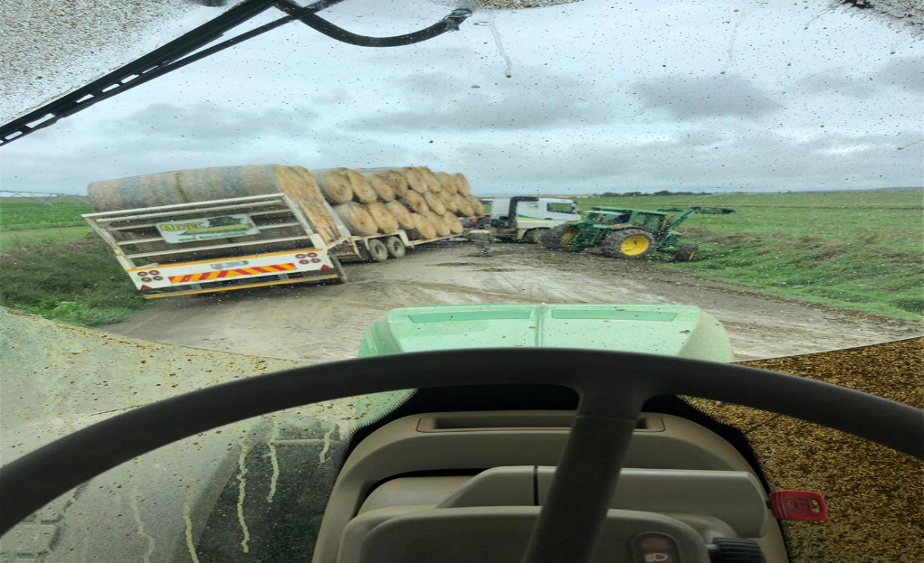

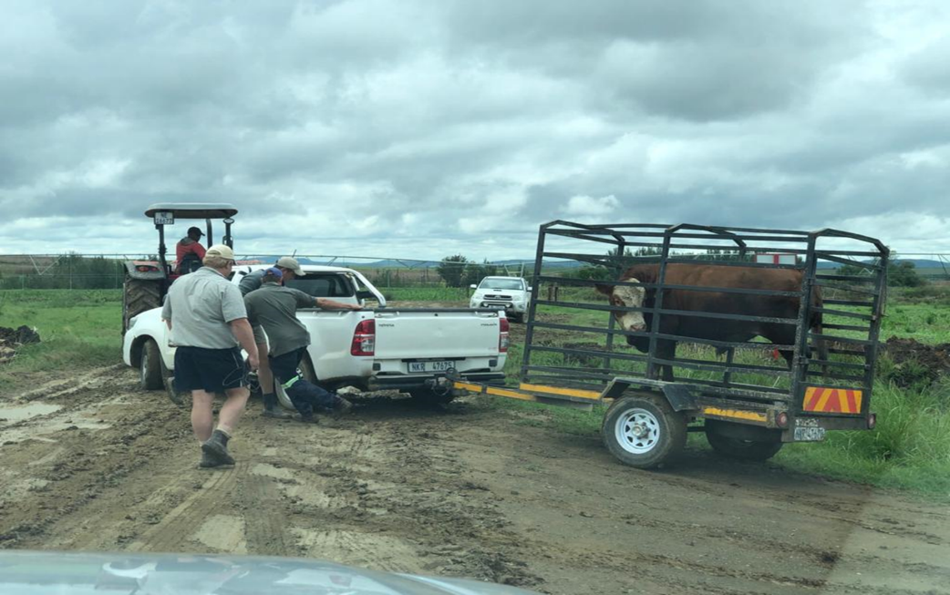

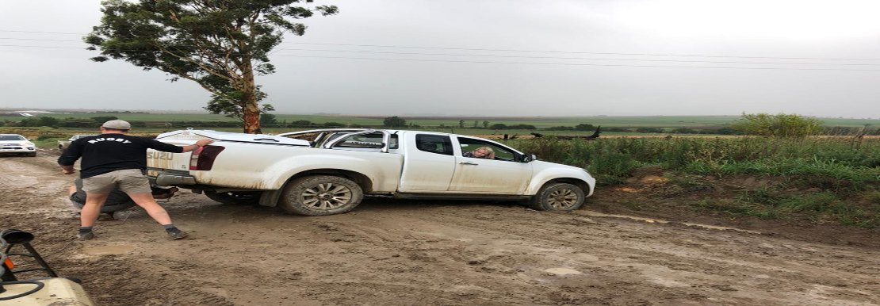

DTIC advised that Okhahlamba Local Municipality make an application for infrastructure funding to DTIC. The funding will be used to rehabilitate the road. UEDA was tasked to guide the municipality in drawing the application and coordinate all the follow up meetings about the road.

# **PARTC: GOVERNANCE**

## CORPORATE GOVERNANCE STATEMENT

**INTRODUCTION**

Corporate Governance embodies processes and systems by which municipal entities are directed, controlled and held to account. In addition to legislative requirements based on a municipal entity’s enabling legislation and companies act, corporate governance with regards to municipal entities is applied through Municipal Finance Management Act(MFMA), Municipal System Act (MSA) and run in tandem with principals contained in The King Code of Governance for South Africa and King Report on Governance (King III)

**COUNCIL**

Uthukela Economic Development Agency (UEDA) report to uThukela District council, which also have an oversight role over the Agency, which includes the appointment and dismissal of the Board of UEDA

**THE ACCOUNTING AUTHORITY**

**INTRODUCTION**

The Board of UEDA is the accounting authority for the entity all Non-Executive Board members of UEDA are appointed in accordance with. The Board members of accountable to the parent Municipality and they owe, a duty of care and diligence to the Municipal entity. They Act in the best interest of the entity and consequently its parent municipality.

The roles and responsibilities of the Board are clearly defined and are also guided by principal of good corporate governance which include inter alia:

* Recruitment of the Chief Executive Officer (CEO).
* Provide strategic direction to the Municipal entity
* The Board has a strategic function in providing the vision mission and goals of the entity.
* These are determined in combination with the CEO and the executive team.
* Retaining full and effective control and management over the affairs of the entity.
* Provide oversight over the performance of the municipal entity.
* Formulates, monitors, reviews corporate strategy, major plan of action, risk policy annual budgets and business plans;
* Ensuring full and timely disclosures of material matters affecting the municipal entity;
* Ensuring implementation of an effective compliance frame work and ensuring that the entity complies applicable laws, regulations and government policy
* The implementation of a code of Conduct environmental issues that may impact on entity.

**BOARD CHARTER**

The board has a formal Board Charter which provides guidance as well as assistance in ensuring all responsibilities of the Board are discharged as required.

**COMOSITION OF THE BOARD**

The details of the Board members appointed by the Council of Uthukela District Municipality are as follows, including an indication of their attendance at meetings.

**Membership and attendance: Board Meetings in 2019-2020**

|  |  |  |  |  |  |  |
| --- | --- | --- | --- | --- | --- | --- |
| **Name** | **Designation** | **Date Appointed** | **Qualification** | **Area of Expertise** | **No. of meetings held** | **No. of meetings attended** |
| Mr. S. Shabalala | Chairperson | 27/06/2017 | Diploma in Business Studies, Certificate in Communication | Investment | 03 | 01 |
| Mr. P.A Stockhill | Deputy Chairperson | 27/06/2017 | Diploma in Agriculture, Certificate in Mediation | Agriculture | 03 | 02 |
| Mrs. M Asmal | Member | 27/06/2017 | BSS, BA honours in psychology, Certificate in HIV/AIDS Counselling, Certificate in Practical Labour Law, Certificates in Mobilising and Training of Trainers in Assets for Community Driven Development and Certificate in Community Health Impact Assessment | Tourism | 03 | 03 |
| Mr A.M Msomi | Member | 27/06/2017 | BSS, Post Grad Diploma in HR and Master of laws | Finance Planning | 03 | 00 |
| Rev. K.D Nduli | Member |  | Diploma in Production Management | Human Resource | 03 | 02 |
| Mr. J.M Mosia | Member | 27/06/2017 | Primary Teacher’s Diploma, Bed, Further Diploma in Education | Finance and Development skills | 03 | 03 |
| Mr. O.D Amla | Member | 27/06/2017 | Diploma in Marketing and Management | Investment and community Development | 03 | 02 |

## AUDIT COMMITTEE REPORT

**APPENDIX F: RECOMMENDATIONS OF THE AUDIT AND PERFORMANCE AUDIT COMMITTEE 2019/2020**

|  |  |  |
| --- | --- | --- |
| Date of meeting | Committee recommendations | Recommendation adopted (Y/N) |
| 08 August 2019 | * **That confirmation of the budgeted positions be reported to the next meeting.** * **That the Covid-19 supply chain management report or review of the MFMA Circular 102 purchases report to be reported in the next meeting.** * **That the Internal Audit plan be approved subject to changes.** | Y  Y  Y |
| 24 August 2019 | * **Amended Annual Financial Statement be submitted to Audit committee members before submission to Auditor General.** | Y |
| 25 October 2019 | * Revenue section to consult the Labor Relations Office to conduct further investigations and ensures that disciplinary processes are instituted against the employee/s * The AG furnishes the committee with a report on the challenges encountered with the progress on the 2018/2019 audits * The chairperson to obtain responses from senior management in relation to the matters affecting 208/2019 audit. * Water Services Authority Manager, CFO and the Municipal Manager to report back on the progress of Umgeni Water Board Contract * That the Administrator and the Municipal manager to review the internal auditor’s membership fees. * The progress made by the management in resolving the findings raised be reviewed through follow up audits | N  Y  Y  Y  Y  Y |
| 16 January 2020 | * The revised Audit Action plan and be circulated to all members for comments. * The report of pending cases and investigation be submitted to the next meeting * Internal audit to review the draft annual report 2018/2019 before submission | Y  Y  Y |
| 17 March 2020 | * That before the municipality close the financials for 2019/20 all Auditor General findings must be corrected. * That the Chief Financial Officer and the General Manager: MHS to submit information of water losses calculations to Internal Audit for review before submission to Auditor General. * That consequence management be constituted to employees who award suppliers whose tax matters are not checked. * That the Acting MM submits a report in the next APAC meeting in terms of the disciplinary processes that have been taken place in relation to businesses awarded without having tax clearance certificate. * That the Chief Financial Officer submits the list of all the irregular, fruitless, wasteful and unauthorized expenditure and list of deviations. | N  Y  N  N  N |
| 30 June 2020 | * **That the approved organogram be forwarded to the Audit committee members for further verification.** * **That the Chief Financial Officer submits a comparative analysis report on UIFW between the 2018/19 and 2019/20 financial year.** * **That management provide a report to the next meeting in terms of the handover plan of the contract from Umgeni.** * **That confirmation of the budgeted positions be reported to the next meeting.** * **That the Covid-19 supply chain management report or review of the MFMA Circular 102 purchases report to be reported in the next meeting.** * **That the Internal Audit plan be approved subject to changes** | Y  Y  Y  Y  Y  Y |

**AUDIT AND PERFORMANCE AUDIT COMMITTEE MEETINGS 2019/2020**

The Audit and Performance Audit Committee was appointed in **01/02/2019**. The Committee is comprised of 5 independent, external members and is required to meet at least 4 times per annum as per the Audit and Performance Audit Committee Charter and the MFMA. However, additional meetings may be called as the need arises. The members attended as follows:

|  |  |  |  |  |  |  |  |
| --- | --- | --- | --- | --- | --- | --- | --- |
| Audit and Performance Audit Committee Meetings | | | | | | |  |
| Member’s Name | **Number of Meetings Attended** | Date of meeting  08 August 2019 | Date of meeting  24 August 2019 | Date of meeting  25 October 2019 | Date of meeting  16 January 2020 | Date of meeting  17 March 2020 | Date of meeting  30 June 2020 |
| Chairperson-Ms N Mchunu  Ms N Mba  Ms T Ngubane  Mr T Makhetha  Mr Dladla | 6  1  5  6  5 | √  √  √ | √  √  √  √  √ | √  √  √  √ | √  √  √  √ | √  √  √ | √  √  √  √ |

**PART D: ANNUAL FINANCIAL STATEMENTS**

## ANNUAL FINANCIAL STATEMENT

|  |  |  |
| --- | --- | --- |
| **UTHUKELA ECONOMIC DEVELOPMENT AGENCY** | |  |
| **REG. NO: 2017/256360/30** |  |  |
| **ANNUAL FINANCIAL STATEMENTS FOR THE YEAR ENDED 30 JUNE 2020** | | |
| **GENERAL INFORMATION** |  |  |
|  |  |  |
| **Board of Members** |  |  |
| Member | Mr. S. Shabalala | Chairperson |
| Member | Mr. P.A Stockhill |  |
| Member | Mrs M. Asmal |  |
| Member | Mr. O.D Amla |  |
| Member | Rev. K.D Nduli |  |
| Member | Mr. J.M Mosia |  |
| Member | Mr. A.M Msomi |  |
| **Legal Form of Entity** | Soc Limited |  |
|  |  |  |
| **Nature of business** | Local Economic Development | |
|  |  |  |
| **Governing Legislation(s)** | MSA, MFMA & Companies' Act | |
|  |  |  |
| **Legal Representatives** | Ramkhelewan Inc. & Shepstone & Wylie | |
|  |  |  |
| **Accounting Officer (CEO)** | Ms D.C.P Mazibuko |  |
|  |  |  |
| **Chief Finance Officer (ACFO)** | Mr. S.J Dlamini |  |

|  |  |  |  |
| --- | --- | --- | --- |
| **UTHUKELA ECONOMIC DEVELOPMENT AGENCY** | | | |
| **REG. NO: 2017/256360/30** |  |  |  |
| **STATEMENT OF FINANCIAL POSITION AS AT 30 JUNE 2020** | | | |
| **Figures in Rand** | **Note(s)** | **2020** | **2019** |
|  |  |  |  |
| ***Assets*** |  |  |  |
| **Current assets** |  |  |  |
| Cash and cash equivalents | **3** | 1,794,992 | 2,863,535 |
|  |  | **1,794,992** | **2,863,535** |
| **Non-Current assets** |  |  |  |
| Property, Plant & Equipment | **4** | 892,818 | 109,404 |
|  |  |  |  |
|  |  | **892,818** | **109,404** |
| **Total Assets** |  | **2,687,811** | **2,972,939** |
|  |  |  |  |
| **Liabilities** |  |  |  |
| **Current liabilities** |  |  |  |
| Accounts Payable |  | 18,950 | - |
| Unspent Conditional Grants | **8** | 1,794,992 | 2,863,535 |
|  |  | **1,813,942** | **2,863,535** |
|  |  |  |  |
| **Total liabilities** |  | **1,813,942** | **2,863,535** |
|  |  |  |  |
| **Net Assets** |  |  |  |
| Accumulated surplus |  | **815,277** | **122,957** |
| **Total net assets** |  | **873,868** | **109,404** |
|  |  |  |  |
| **Total Equity and Liabilities** |  | **2,687,811** | **2,972,939** |

|  |  |  |  |  |  |
| --- | --- | --- | --- | --- | --- |
|  |  |  |  |  |  |
| **UTHUKELA ECONOMIC DEVELOPMENT AGENCY** | | |  |  |  |
| **REG. NO: 2017/256360/30** |  |  |  |  |  |
| **STATEMENT OF FINANCIAL PERFORMANCE FOR THE YEAR ENDED 30 JUNE 2020** | | | | | |
| **Figures in Rand** | **Note(s)** | **2,020** | **2,019** |  |  |
| **Revenue** |  |  |  |  |  |
| ***Revenue from non-exchange transactions*** |  |  |  |  |  |
| Transfers and subsidies | **8** | 1,509,278 | 348,070 |  |  |
| Transfer Payment: uThukela District Municipality | **8** | 1,710,461 | 1,608,415 |  |  |
| Rental Grant | **8** | 261,256 | - |  |  |
| ***Revenue from non-exchange transactions*** |  | **3,480,995** | **1,956,485** |  |  |
|  |  |  |  |  |  |
| ***Revenue from exchange transactions*** |  |  |  |  |  |
| Interest received/earned | **13** | 52,902 | 13,734 |  |  |
| ***Revenue from exchange transactions*** |  | **52,902** | **13,734** |  |  |
|  |  |  |  |  |  |
| **Total Revenue (A)** |  | **3,533,897** | **1,970,218** |  |  |
|  |  |  |  |  |  |
| Transfer expenditure | **5** | 1,710,461 | 1,496,200 |  |  |
| Depreciation & Amortization |  | 80,707 | 2,811 |  |  |
| Bank charges |  | 1,353 | 180 |  |  |
| Grant expenditure/ RASET |  | 898,111 | 150,019 |  |  |
| Accruals: Lights & water/Accommodation |  | 27,988 | 198,051 |  |  |
| **Total Expenditure (B)** |  | **2,718,619** | **1,847,261** |  |  |
|  |  |  |  |  |  |
| **Operational surplus** |  | **815,277** | **122,957** |  |  |
| **Surplus/(Deficit) for the year (A-B)** |  | **815,277** | **122,957** |  |  |

|  |  |  |  |  |
| --- | --- | --- | --- | --- |
|  | **UTHUKELA ECONOMIC DEVELOPMENT AGENCY** | | |  |
|  | **REG. NO: 2017/256360/30** | |  |  |
|  |  |  |  |  |
|  |  |  |  |  |
|  | **STATEMENT OF CHANGES IN NET ASSETS FOR THE YEAR ENDED 30 JUNE 2020** | | | |
|  |  |  |  |  |
|  | **Figures in Rand** |  | **Accumulated surplus** | **Total net assets** |
|  |  |  |  |  |
|  | **Balance 30 June 2019** |  | **122,957** | **109,404** |
|  |  |  |  |  |
|  | Surplus for the period |  | 815,277 | 873,868 |
|  |  |  |  |  |
|  | **Balance 30 June 2020** |  | **938,234** | **983,273** |

|  |  |  |  |
| --- | --- | --- | --- |
| **UTHUKELA ECONOMIC DEVELOPMENT AGENCY** | | |  |
| REG. NO: 2017/256360/30 |  |  |  |
| **CASH FLOW STATEMENT FOR THE YEAR ENDED 30 JUNE 2020** | | | |
| **Figures in Rand** | **Note(s)** | **2020** | **2019** |
|  |  |  |  |
| **Cash flow from operating activities** |  |  |  |
| **Receipts** |  |  |  |
| Transfers and subsidies |  | 853,925 | 3,000,000 |
| Interest Receipts |  | 39,168 | 13,734 |
|  |  | **893,094** | **3,013,734** |
|  |  |  |  |
| **Payments** |  |  |  |
| Contracted services: RASET |  | (843,208) | (150,019) |
| Bank charges |  | (1,353) | (180) |
| Rent paid |  | (252,954) | - |
|  |  | **(1,097,515)** | **(150,199)** |
|  |  |  |  |
| **Net cash flow from operating activities** |  | (204,422) | 2,863,535 |
|  |  |  |  |
| **Cash flows from investing activities** |  |  |  |
| Purchase of property, plant and equipment |  | (864,121) | - |
| Purchase of intangible assets |  | - | - |
| Purchase of financial assets |  | - | - |
|  |  |  |  |
| **Net cash flow from investing activities** |  | (864,121) | - |
|  |  |  |  |
| **Cash flows from financing activities** |  | - | - |
| Movement long term loan |  | - |  |
|  |  |  |  |
|  |  |  |  |
| **Net increase/decrease in cash and cash equivalents** |  | (1,068,543) | 2,863,535 |
| Cash and cash equivalents from the beginning of year |  | 2,863,535 | - |
| **Cash and cash equivalents end of year** | **3** | **1,794,992** | **2,863,535** |